Legislative
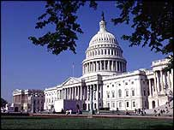
El Capitolio es la sede del Congreso

The legislative branch of government, established in Article I of the Constitution, makes new national laws and modifies existing ones. Under the Constitution this duty is carried out by the Congress, a bicameral body divided into the Senate and House of Representatives. Members of both chambers are directly elected by the people of the state they represent. The House of Representatives has 435 members, with the number representing each state decided according to population size, elected every two years. The Senate is based on equal representation, with each state supplying two of the 100 members, and each has a six-year term.

The founding fathers wanted to check the power of the majority by giving smaller states extra representation, and gave Senators a longer term in office so that they would be less subject to popular pressures.

Congress
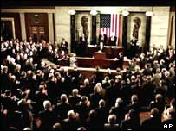
Una joint session en el Congreso

Congress has wide-ranging powers including control over federal taxing and spending and the right to coin money or declare war on other countries. Its primary duty is to write, debate and pass bills before they are sent to the president. Money bills can only originate in the House, but both houses need to approve a bill before it can be passed.

Another key task is overseeing the executive branch of government. Congressional committees are tasked with ensuring the government is being run competently and without corruption. To assist in this they can summon senior officials for questioning and demand audits of executive agencies. Congress can also hold hearings on matters of general public concern.

How the president can check the legislature:

* Can veto a bill Congress has passed
* Can call special sessions and force an adjournment when both Houses cannot agree on adjournment
* Can temporarily appoint senior officials without Senate approval when it is in recess
* Congress cannot reduce the president's salary while he or she is in office.

How the judiciary can check the legislature:

* Has the power to declare laws unconstitutional
* Congress cannot reduce a judge's salary while he or she is in office
- Chief justice presides over impeachment trials.

Congressional Agencies
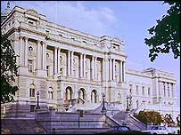
Library of Congress

As congressional work has grown and become more complex, Congress has come to rely on the advice and assistance of a large number of auxiliary agencies and a large congressional staff. One of the most important agencies is the Congressional Budget Office, a group of experts in economics and statistics, who aid legislators by providing independent, impartial advice on the president's budget proposals. Another is the Library of Congress, which serves Congress as a research facility, and is also the US national library and home to some of its most precious texts, including copies of the Declaration of Independence and the Constitution.

Executive
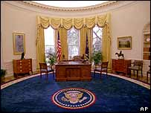
El presidente despacha desde la Oficina Oval

The executive branch of government is responsible for enforcing the laws of the land. It is made up of the president, the vice-president, the Cabinet and a number of what are known as independent agencies. At the head of the executive branch is the US president, who must "take care that the laws be faithfully executed" and "preserve, protect and defend" the Constitution. In order to carry out this duty, he or she presides over a vast organisation of federal departments and agencies, which has grown over the course of history and now employs about four million people.

President
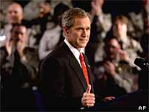
George W. Bush, actual presidente de los EUA

In addition to leading the executive branch, the president is the head of state and commander in chief of the military. The president's duties include negotiating international treaties, signing or vetoing bills, appointing members of the Cabinet, judiciary and ambassadors and issuing pardons for federal offences. Thanks to its superpower status the US president is often cited as the most powerful person on Earth. But while the office does have significant authority it is limited by the checks and balances enshrined in the Constitution. However the power of the press and the importance of foreign policy has enormously boosted the authority of the president in recent times.

How the legislature can check the president:

* Can refuse to pass a bill the president wants or to approve presidential appointments
* Must approve budget, declarations of war and treaties
* Can override presidential vetoes and use impeachment powers to remove the president from office
* Chooses the winner of a presidential or vice-presidential election when no candidate has a majority of electoral college votes
* President must periodically report to Congress by delivering a State of the Union address

How the judiciary can check the president:

* Can declare executive orders unconstitutional
* Chief justice sits as president of the Senate during presidential impeachment trials

Cabinet
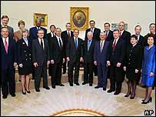
Bush y su ganibete

The Cabinet is traditionally made up of the vice-president and the heads of the 15 executive departments - agriculture, commerce, defence, education, energy, health and human services, homeland security, housing and urban development, interior, labour, state, transportation, treasury, veterans' affairs, and the attorney general. These department heads are appointed by the president, and must be approved by a majority vote of the Senate. Other officials or agencies can be given Cabinet rank if the president chooses.

Cabinet members must work closely with the congressional committees who control their budgets and write the laws they have to implement. While some cabinet members are key advisors to the president, others may essentially serve in a more adminstrative capacity.

Executive office of the president
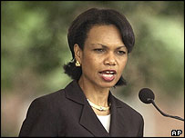
La Consejera Nacional de Seguridad, Condoleezza Rice, pertenece al NSC

The staff of the executive office serves the president directly and when he or she is replaced the office may be completely reorganised. The bodies which make up the executive office advise the president and carry out the detailed work of implementing presidential policies and programmes. Playing leading roles in the executive office are the National Security Council (NSC) and the Office of Management and Budget (OMB). The NSC advises and assists the president on national security and foreign policy matters. It is chaired by the president and includes the vice-president, national security adviser and secretaries of state, defence and the treasury. The OMB assists the president in overseeing the preparation of the federal budget and formulating the president's spending plans.

Vice-President
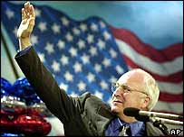
Dick Cheney, Vice-Presidente de los EUA

The vice-president is the second-highest executive officer and assumes the top role if the president cannot continue in office. He or she serves as president of the Senate, overseeing procedural matters, and has the ability to cast a deciding vote in the event of a tie. The vice-president also presides over a joint session of Congress when it formally counts electoral votes for presidential elections. The role grew in strength in the 20th Century when it became customary to invite vice-presidents to Cabinet meetings and when, in 1949, Congress made the vice-president one of four statutory members of the National Security Council.

Independent agencies
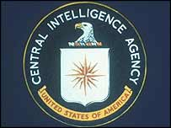
El papel de la CIA no está delineado en la Constitución

There are several administrative divisions of the executive branch whose roles have been separated from formal control of the president and are considered independent extensions of the government. These agencies and commissions are established by Congress to help execute policy or provide special services. They are diverse in make-up and responsibilities and include the Central Intelligence Agency, the Post Office, and the Environmental Protection Agency.

Judicial
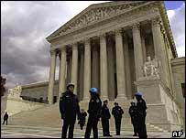
La Suprema Corte es la sede del Judicial

It is the job of the judicial branch of the government to interpret the laws passed by Congress. It consists of the Supreme Court and the lower federal courts. In interpreting the law the courts may find that a law - including those passed by individual states - violates the Constitution. By declaring a law unconstitutional the courts play an important role in determining the law of the land.

Supreme Court
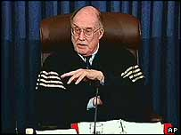
William Rehnquist, chief justice actual

The Supreme Court is the highest court in the US. Its decisions cannot be appealed and can only be changed by another Supreme Court decision or a constitutional amendment. The number of justices serving on the court is determined by Congress rather than the Constitution, but since 1869 it has always consisted of one chief justice and eight associate justices. They are nominated by the president and approved by the Senate, and have their jobs for life, unless they resign, retire, or are removed from office. The key responsibilities of the Supreme Court is to examine laws and government actions to ensure they do not violate the principles laid down in the Constitution. This practice, known as judicial review, allows the court to strike down laws that do not conform to the Constitution.

How the president can check the judiciary:

* Appoints judges
* Has power to pardon convicted criminals

How the legislature can check the judiciary:

* Approves federal judges
* Has power to impeach and remove judges
* Can initiate constitutional amendments and can alter the size and structure of courts
* Sets court budgets

Lower courts
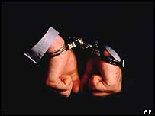
Las cortes federales procesan los crímenes a leyes federales

Along with the establishment of a supreme court, Article III of the US Constitution calls for Congress to create any other federal courts necessary to interpret and apply the federal laws of the land. In response Congress has created a number of district courts, appeal courts and several specialised courts such as the Tax Court, which hears cases regarding federal taxes. There are 94 district courts spread throughout the US and its overseas territories. They are the trial courts of the federal judicial system and have jurisdiction in federal criminal cases and civil cases. There are 13 courts of appeals - one for each of the 11 geographical regions, called circuits, one for the District of Columbia, and one hearing cases from specialised lower courts. These 13 courts hear cases on appeal from the federal district courts and other lower courts.

However, most legal cases in the US - including nearly all criminal cases - are tried by state courts, using state laws, which can vary greatly between states (for example, in the use of the death penalty).

